

## Project Name: BEAUTY PARLOUR MANAGEMENT SYSTEM

## Course Name: INTRODUCTION TO DATABASE

## Section: [A]

## DATE OF SUBMISSION: 17-05-2020

## Group members:

|  |  |
| --- | --- |
| NAME | ID |
| 1.MUSTAQ, SUFIAN | 19-39292-1 |
| 2.COSTA, PIU TERESA | 18-38286-2 |
|  | 19-39653-1 |
|  |  |

|  |  |
| --- | --- |
| Contents | PAGE NUMBER |
| 1.Cover Page | Page | 01 |
| 2.Introduction | Page | 03 |
| 3.Scenario Description | Page | 03 |
| 4.ER Diagram | Page | 07 |
| 5.Normalization | Page | 08 |
| 6.Schema Diagram | Page | 13 |
| 7.Table Creation | Page | 14 |
| 8.Data Insertion | Page | 16 |
| 9.Query Writing | Page | 19 |
| 10.Relational Algebra | Page | 22 |
| 11.Conclusion | Page | 23 |
|  |  |

***Introduction:***

Beauty parlor management system is a system where it is designed to keep the data about employees who work in the parlor and also the owner’s information. The system also can stored the customer’s details like their name, address, how much they pay for the services they had etc. This system is designed to provide the owners as well as the employees to manage and modify certain levels of the database to update the information about the required fields. The administrator will also have the privilege to add or remove the employee’s information. There are also treatments that the parlor provided can be stored. The information about the parlor property also stored in parlor database. Customers can also make appointment before coming to the parlor which store in database with time and date. The main aim of the system is to provide an easy to manage and maintain data storage and modification facility for the parlor.

***Scenario:***

In a beauty parlor management system, customers can have many treatments from the parlor. . A customer is identified by a unique customer id, customer name, payments and phone number. Treatment is identified by unique service no, fees, manicure, pedicure, waxing, threading, massage. Customers can make payment in many ways. Payment is identified by a unique payment id, record, cash, Credit. Payments can be ready and paid in many ways into beauty parlors. On the other hand, many treatments can be done in the beauty parlors. Beauty parlor is identified by a unique code no, appointments, employees’ availability and payment records. Treatments can be performed by many employees. Employees can be recognized by a unique id, Phone-number, name, salary, work-time, profession, address. One property can deal with many beauty parlors and one property may have many owners. Owner who owns the property, is identified by his/her name, address, a unique id, phone number. Property has a unique id, address city and country. And that is how a beauty parlor management system run.

***Case Study:***

Based on the requirements of the system, the entities and the relations were identified and designed as follows:

**Entities:**

1. **Customer:** The customer has the entity to have the treatments from the parlor. It has                              following attributes :
2. Customer ID (Primary key)
3. Customer name
4. Payments.
5. Phone-number (multivalued attribute)
6. **Owner:** Owner is the entity where all the information about Owner is stored. This entity will have the following attributes:
7. Owner ID (Primary key)
8. Owner name
9. Address
10. Phone-number(multivalued attribute )
11. **Employee:** This entity works in the parlor. This entity will have the following attributes:
12. Employee ID (Primary key).
13. Employee name.
14. Work-time
15. Salary.
16. Address
17. Phone (multivalued attribute)
18. Profession
19. **Treatment:** This entity covers the details about the treatments that the parlor provided. This entity will have the following attributes:
20. Service no (Primary key).
21. Fees.
22. Manicure.
23. Pedicure.
24. Facial.
25. Waxing.
26. Threading.
27. Massage.
28. **Property:** This entity covers the information about the property of the parlor. This entity will have the following attributes:
29. Property id (Primary key).
30. Address.
31. City.
32. Country.
33. **Payment:** This entity covers the payment related information. This entity will have the following attributes:
34. Payment ID (Primary key).
35. Record.
36. Cash.
37. Due.

.

1. **Beauty parlor:** This entity covers the details of the parlor information. This entity will have the following attributes:
2. Code no (Primary key).
3. Appointments.
4. Payment record.
5. Employees’ availability.

**Relations:**

1. **Customer to Treatment:** Customers can take many treatments from the parlor also many customers can take treatments. So, there will be many to many relations between them.
2. **Customer to Payment:** Customers can pay for the treatments in many ways. Many customers can make payment. So, there will be many to many relations between them.
3. **Owner to Property:**  Owners have one property for the parlor but the property has many owners. So, there will be one to many relations between them.
4. **Property to Beauty Parlor:** The property deals with many information about the beauty parlor and beauty parlors only deal with one property. So, there will be one to many relations between them.
5. **Treatment to Beauty Parlor:** Many treatments can be done in the parlor. So, there will be many to many relations between them.
6. **Treatment to Employee:** many treatments are done by employees. And many employees can do the treatments. So, there will be many to many relations between them.
7. **Payment to Beauty Parlor:** Payments can be ready and paid in many ways into beauty parlor. So, there will be many to many relations between them.

***ER-DIAGRAM:***

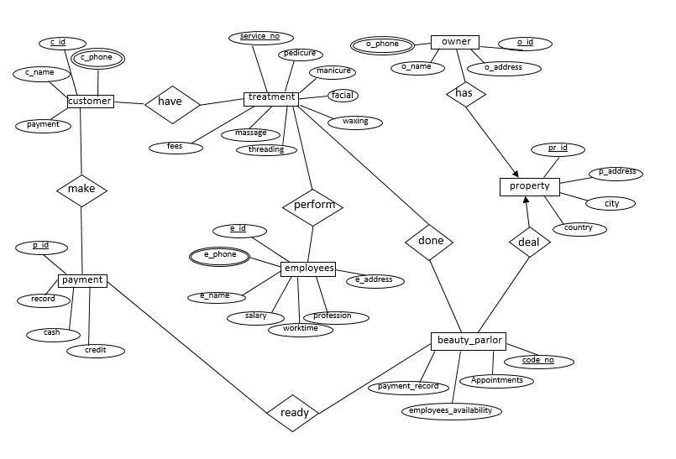

***Normalization:***

1. **Make(c_id , c_name , payment , c_phone , p_id , record , cash ,Due)**

**1NF:**      c_ phone is multivalued attribute

**2NF:**      c_id , c_name , payment ,c_ phone

               p_id , record , cash , Due

***Relation many to many:***

               c_id , c_name , payment , c_phone

               p_id , record , cash , Due

               Pc_id , c_id , p_id

**3NF:**     no transitive dependency available

                c_id , c_name , payment , c_phone

                p_id , record , cash , due

               Pc_id , c_id , p_id

**Total table :**

1. c_id , c_name , payment , c_phone

2. p_id , record , cash , due

3. Pc_id , c_id , p_id

1. **Have(c_id , c_name , payment , c_phone , service_no , pedicure , manicure , facial , massage , fees , threading , waxing)**

**1NF :** c_phone multivalued attribute

**2NF:**    c_id , payment , c_name , c_phone

 Service_no , pedicure , manicure , facial , massage , fees , threading , waxing , massage

***Relation many to many:***

c_id , payment , c_name , c_phone

Service_no , pedicure , manicure , facial , massage , fees ,threading , waxing , massage

cs_id , c_id , service_no

**3NF :** no transitive dependency available

c_id , payment , c_name , c_phone

Service_no , pedicure , manicure , facial , massage , fees ,threading , waxing , massage

cs_id , c_id , service_no

**Total table :**

1. c_id , payment , c_name , c_phone

2. Service_no , pedicure , manicure , facial , massage , fees , threading , waxing , massage

3.cs_id , c_id , service_no

1. **Has(o_id , o_phone , o_name , o_address , pr_id , p_address , city , country)**

**1NF**:o_ phone multivalued attribute

**2NF:** o_id , o_phone , o_name , o_address

         pr_id , p_address , city , country

***Relation one to many:***

         o_id , o_phone , o_name , o_address  , pr_id

         pr_id , p_address , city , country

**3NF:** transitive dependency available

         o_id , o_phone , o_name , o_address  , pr_id

         pr_id , p_address , cc_id

        cc_id , city country

**total table :**

1.  o_id , o_phone , o_name , o_address  , pr_id

2. pr_id , p_address , cc_id

3. cc_id , city country

1. **Deal(pr_id , p_address , city , country , code_no , appointments , payment_record , employees_availability)**

**1NF:** no multivalued attribute available

**2NF :** pr_id , p_address , city , country

 code_no , appointments , payment_record , employees_availability

***Relation one to many:***

pr_id , p_address , city , country

code_no , appointments , payment_record , employees_availability , pr_id

**3NF:** transitive dependency available

pr_id , p_address , cc_id

code_no, appointments , payment_record , employees_availability ,     pr_id

 cc_id , city , country

**total table :**

1.pr_id , p_address , cc_id

2.code_no , appointments , payment_record , employees_availability ,     pr_id

3. cc_id , city country

1. **Done ( service_no , massage , manicure , pedicure , waxing , threading , facial , fees , code_no , appointments , payment_record , employees_availability )**

**1NF:** no multivalued attribute available

**2NF:** service_no , massage , manicure , pedicure , waxing , threading , facial , fees

code_no , appointments , payment_record , employees_availability

***Relation many to many:***

service_no , massage , manicure , pedicure , waxing , threading , facial , fees

 code_no , appointments , payment_record , employees_availability

sc_id , service_no , code_no

**3NF :** no transitive dependency available

service_no , massage , manicure , pedicure , waxing , threading , facial , fees

code_no , appointments , payment_record , employees_availability

sc_id , service_no , code_no

**Total table :**

1.service_no , massage , manicure , pedicure , waxing , threading , facial , fees

2.code_no , appointments , payment_record , employees_availability

3.sc_id , service_no , code_no

1. **Perform(service_no , massage , manicure , pedicure , waxing , threading , facial , fees , e_id , worktime , e_address , salary , e_phone , professional)**

**1NF:** e_phone multivalued attribute

**2NF:** service_no , massage , manicure , pedicure , waxing , threading , facial , fees

 e_id , worktime , e_address , salary ,e_ phone , profession

***Relation many to many :***

service_no , massage , manicure , pedicure , waxing , threading , facial , fees

e_id , worktime , e_address , salary ,e_ phone , profession

se_id , service_no , e_id

**3NF :** no transitive dependency available

service_no , massage , manicure , pedicure , waxing , threading , facial , fees

e_id , worktime , e_address , salary ,e_ phone , profession

se_id , service_no , e_id

**Total table :**

1.service_no , massage , manicure , pedicure , waxing , threading , facial , fees

2.e_id , worktime , e_address , salary ,e_ phone , professional

3.se_id , service_no , e_id

1. **Ready(p_id , record , cash , due , code_no , appointments , payment_record , employees_availability)**

**1NF:** no multivalued attribute available

**2NF :** p_id , record , cash ,due

         code_no , appointments , payment_record , employees_availability

***Relation many to many:***

p_id , record , cash , due

 code_no , appointments , payment_record , employees_availability

cp_id , p_id , code_no

**3NF :** no transitive dependency available

p_id , record , cash , due

 code_no , appointments , payment_record , employees_availability

cp_id , p_id , code_no

**Total table :**

1.p_id , record , cash , due

2. code_no , appointments , payment_record , employees_availability

3.cp_id , p_id , code_no

***TOTAL TABLE***

1. c_id , c_name , payment , c_phone
2. p_id , record , cash , due
3. Pc_id , c_id , p_id
4. ~~c_id , payment , c_name , c_phone~~
5. Service_no , pedicure , manicure , facial , massage , fees, threading , waxing , massage
6. cs_id , c_id , service_no
7. o_id , o_phone , o_name , o_address  , pr_id
8. pr_id , p_address , cc_id
9. cc_id , city country
10. ~~pr_id , p_address , cc_id~~
11. code_no , appointments , payment_record , employees_availability ,     pr_id
12. ~~cc_id , city country~~
13. ~~service_no , massage , manicure , pedicure , waxing , threading , facial , fees~~
14. ~~code_no , appointments , payment_record , employees_availability~~
15. sc_id , service_no , code_no
16. ~~service_no , massage , manicure , pedicure , waxing , threading , facial , fees~~
17. e_id , worktime , e_address , salary ,e_ phone , profession
18. se_id , service_no , e_id
19. ~~p_id , record , cash , credit~~
20. ~~code_no , appointments , payment_record , employees_availability~~
21. cp_id , p_id , code_no

Total table no - 13

***Final Table:***

1. c_id , c_name , payment , c_phone
2. p_id , record , cash , due
3. Pc_id , c_id , p_id
4. Service_no , pedicure , manicure , facial , massage , fees, threading , waxing , massage
5. cs_id , c_id , service_no
6. o_id , o_phone , o_name , o_address  , pr_id
7. pr_id , p_address , cc_id
8. cc_id , city country
9. code_no , appointments , payment_record , employees_availability ,     pr_id
10. sc_id , service_no , code_no
11. e_id , worktime , e_address , salary ,e_ phone , profession
12. se_id , service_no , e_id
13. cp_id , p_id , code_no

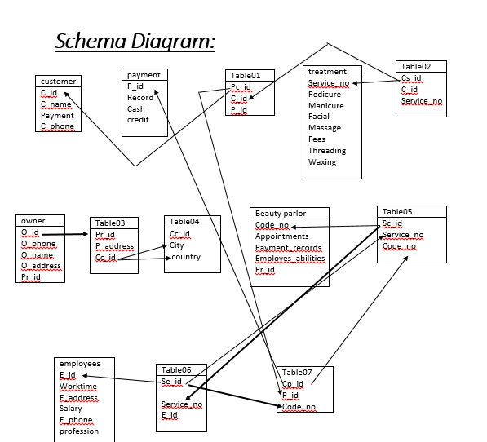

***Table Creation:***

**Customer Table:**

create table customer(c_id number(10)primary key, c_name varchar2(20), payment number(10), c_phone number(10));

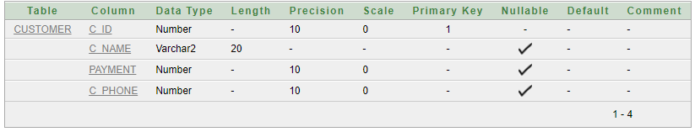

**Payment Table:**

create table payment (p_id number(10)primary key, record varchar2(20), cash varchar2(20), due varchar2(20));

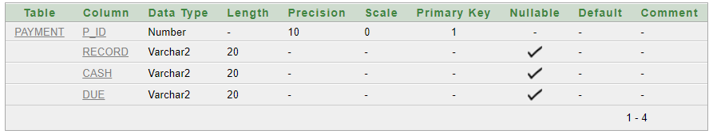

**Treatment Table:**

create table treatment( Service_no number(10)primary key, Pedicure varchar2(20), Manicure varchar2(20), Facial varchar2(20), Massage varchar2(20), Fees varchar2(20), Threading varchar2(20), Waxing varchar2(20));

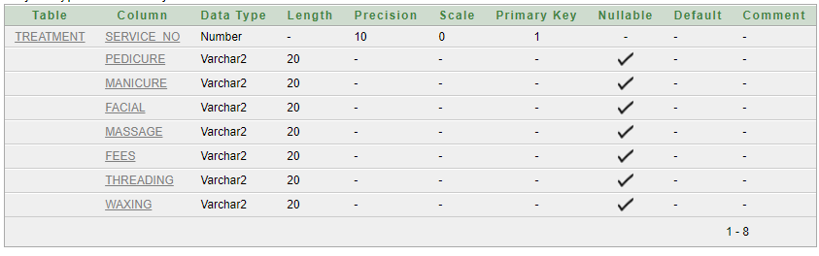

**Owner Table:**

create table Owner(O_id_ number(10)primary key, O_phone number(10), O_name varchar2(20), O_address varchar2(20), pr_id_FK number(10));

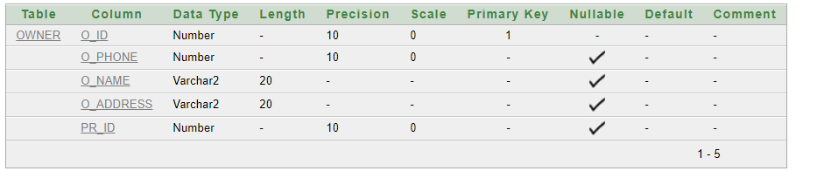

**Beauty Parlor Table:**

create table beautyparlor( code_no number(10)primary key, Appointments varchar2(20), payment_records number(10), Employees_abilities varchar2(20), Pr_id number(10));

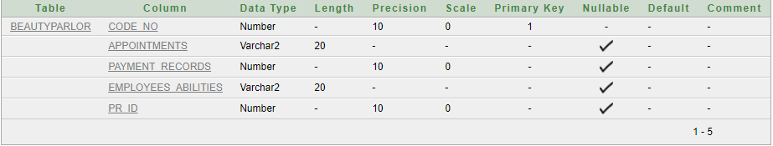

**Employees Table:**

create table employees(e_id number(10)primary key, worktime number(10), E_address varchar2(20), salary number(10), E_phone number(10), profession varchar2(20));

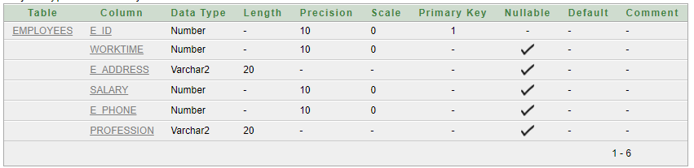

**Property Table:**

create table property (Pr_id number(10)primary key, P_Address varchar2(20), city varchar2(20), country varchar2(20));

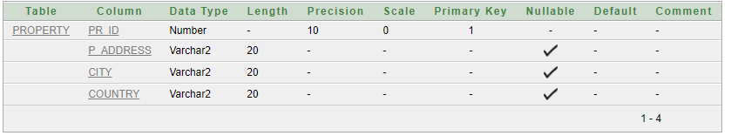

***Value Insertion:***

**Customer Table:**

insert into customer values('1111','Sufian','2424','0170671242');

insert into customer values('2222','Anisha','3225','0176598321');

insert into customer values('3333','Sabbir','2536','0174785963');

insert into customer values('4444','Sumit','9874', '0173624189');

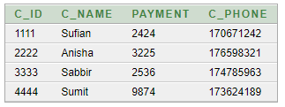

**Payment Table:**

insert into payment values('12','3:15 PM','5836 TK','0.00 TK');

insert into payment values('13','10:28 PM','6780 TK','0.00 TK');

insert into payment values('16','6:15 PM','10980 TK','0.00 TK');

insert into payment values('20','4:59 PM','1573 TK','0.00 TK');

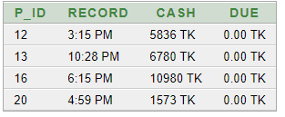

**Treatment Table:**

insert into treatment values ('10','Fish','Basic','Gold','Reflexogy','regular pack 5000 TK','Eyebrows', 'Full Hand');

insert into treatment values ('13','Regular','French','Whiting','Thai','premium pack 7000 TK','Upper Lip', 'Underarms');

insert into treatment values ('15','French','American','Spa','Oil','Gold pack 10000 TK','Full Face','FullLeg');

insert into treatment values ('18','Spa','Mirror','Green Tea','Aroma Therapy','Diamond pack 15000 TK','Side Face','HalfLeg');

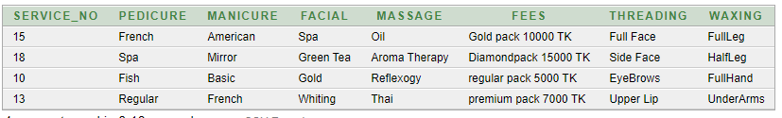

**Owner table:**

insert into Owner values ('01','0165893247','Piu','Farmgate','1254');

insert into owner values ('02','0165892569','Mustaq','Basundhara','2479');

insert into owner values ('03','0161429832','sams','Basundhara','2589');

insert into owner values ('04','0183641000','Sabbirul','dhanmondi','3566');

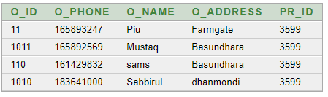

**Beauty parlor Table:**

insert into beautyparlor values('12','11 AM','5000','Tazul Islam','2479');

insert into beautyparlor values('13','2 PM','8000','Zunayed Hossain','2589');

insert into beautyparlor values('14','4 PM','10000','Sumaya Irina','1254');

insert into beautyparlor values('15','5PM','10000','Dipty Moni','3566');

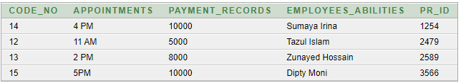

**Employees Table:**

insert into employees values('398','Tazul Hossain','10AM-8PM','Malibag','5000','0173569871','Cleaner');

insert into employees values('452','Zunayed Hossain','11AM-7PM','Mirpur','7000','0179634789','Cashier');

insert into employees values('460','Dipty Moni','12PM-6PM','Mirpur','20000','01765986','Makeup Artist');

insert into employees values('461','Sumaya Irina','12PM-6PM','Bashabo','20000','0173694785','Makeup Artist');

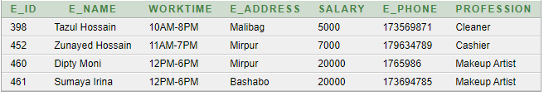

**Property Table:**

insert into property values ('2589','Dhanmondi','Dhaka','Bangladesh');

insert into property values ('3566','Gulshan','Dhaka','Bangladesh');

insert into property values ('1254','Basundhara','Dhaka','Bangladesh');

insert into property values ('2479','Binodpur','Rajshahi','Bangladesh');

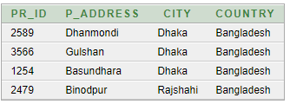

***QUEARY WRITING:***

**SINGLE ROW FUNCTION:**

1. Find out the length all employees ename and also find the position of ’i’ on their first name .

Select C_name , length(C_name) , instr(C_name,'i')

From customer;

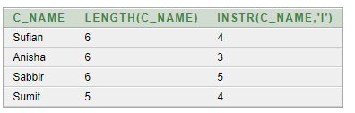

1. Concatenate the columns name and  id for all employees from emp and add the literal id is between the two columns.

 Select C_name || ' id is ' || c_id

From customer;

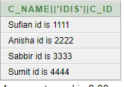

**GROUP FUNCTION:**

1. Display the sum of salaries grouped by the profession and employee id but the sum of the salary must be lower than 20000 .

select E_id ,profession, SUM(salary)

from mployees

having SUM(salary)<20000

group by E_id ,profession;

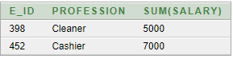

1. Find average , maximum, minimum & summation salary of the employees .

Select avg(salary), max(salary), min(salary), sum(salary)

From mployees;

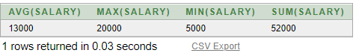  
  
  
**SUB QUEARY:**

1.To display C_ID, C_NAME, PAYMENT C_PHONE of the students from customer table whose section is C_ID=2222.

Select C_ID, C_NAME, PAYMENT C_PHONE from customer

WHERE C_ID IN

(SELECT C_ID from customer where C_ID='2222');



2.Display employee id and salary who earn more than employee number 452.

Select E_id ,salary

From mployees

Where salary >(select salary from mployees where E_id=452);

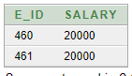

**JOINING:**

1. Display owner id , name & address from Owner and parlor code no & parlorID from beauty parlor .

SELECT Owner.O_ID_, Owner.O_NAME, Owner.O_ADDRESS, beautyparlor.CODE_NO, beautyparlor.PR_ID

FROM Owner, beautyparlor

WHERE Owner.PR_ID_FK=beautyparlor.PR_ID;

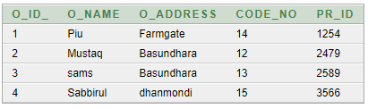

2. Display Payment id from payment and customer id from customer.

SELECT payment.P_ID,customer.C_ID

FROM payment, customer

WHERE payment.P_ID(+)= customer.C_ID;

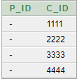

**View:**

1. Create a view called treatment view01 based on the pedicure, manicure, & Fees from the table treatment.

CREATE VIEW treatmentview01 AS SELECT pedicure ,manicure , fees from treatment ;

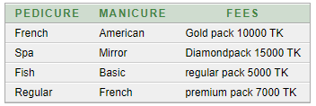

2. Using Your treatmentview01 enter a query to display pedicure where pedicure is fish.

select pedicure from treatmentview01 where pedicure ='Fish' ;



***Relational Algebra :***

**1. Find the name of the customer whose customer id is 1111.**

∏c_name (σ c_id=1111(Customer))

**2. Find the employee id where salary is less than 6000**

∏*e_id* (σ*salary* <6000 (Employees))

**3. Find owner’s id and owner’s name where address is Dhanmondi.**

∏*o_id,o_name* (σ*address=”dhanmondi”* (*Owner*))

**4. Find the name of owner, property id and city whose name is Sams.**

∏*o_name,pr_id,city* (σ*o_name*=“sams” *(owner* **⋈** *property))*

**5. Find the name and id of the employee who lives in Malibag.**

∏e_name,e_id (σ e_address=”mailbag”(Employee))

**Conclusion:**

During the time of completing this project, many conditions were experienced which are not normally understood during the theoretical study. Moreover, the workflow was also learned as the tables needed to be created based on the dependency models. The best practices for creating a database as well as a good plan to do that were analyzed. The importance of a robust ER diagram design as well as a correct normalized structure was also understood. The whole project was a scope to understand the result and practical use of the concepts learned through the whole course. This was possible due to the teamwork of the team members who worked with their best ability to make the project a successful one.

# 

# *THANK YOU*

# 